The Determination of Planck’s Constant using LEDs, 1st Year Laboratory

Martin He, Student at *Imperial College London*

**Abstract** We calculated the value of Planck’s constant (*h*) through the measurement of current-voltage characteristics across several LEDs with certain wavelengths (λ) found through a spectrometer, and then back-extrapolated from the resultant graphs to determine their threshold voltages (VT). Plotting a graph of these values of VT against $\frac{1}{λ}$ consequently means that a gradient can be obtained, which in turn is used to work out *h*. Our experimental value was (6.90± 0.3)×10-34 J.s which was *4.13% off* the defined, accepted value of 6.62607015×10-34 J.s [1].

1. Introduction

P

LANCK’S constant, represented by the letter *h*, is a fundamental Physical constant with wide-ranging applications across many fields. Its inception came about from Max Planck’s *(whom the constant is eponymously-named after)* efforts at the turn of the 19th century to explain the emissions of light from black bodies [2]i, in *Planck’s Law*. The same number was later famously used to express the energy carried by a single photon [3] as being directly proportional to its frequency, with Planck providing the mediating constant.

1. Theory

In order to obtain its value, we must begin with Planck’s equation, relating photon energy to its characteristic frequency:

$E = h ·$*f* **(1)**

whereby *E* is photon energy *(J)* and *f* is the frequency *(Hz).*

We also know that the energy of a charged particle, Eq, accelerated through voltage, V, is given by:

$E_{q} = q · V$**(2)**

Thus, we obtain for an electron of charge e, that $E_{e}=q · V$**(3)** and therefore if by setting the power supply to our LED, so $E_{e}=e · V>E_{g}$**(4)**, which means that electrons are driven from the valence band to the conduction band [4], and can then recombine, emitting photons, energy Eg .

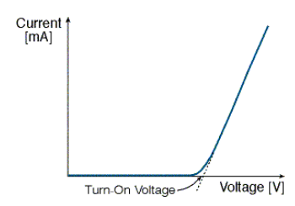

Figure 1: A graph displaying the I-V Characteristics of an LED.[5]

The threshold voltage, or “turn-on” voltage, denoted VT,is calculated through a back-extrapolation from the portion of the graph at voltages beyond VT that approximate linear behaviour. By continuing this linear trend backwards until the *x-intercept*, we obtain VT. It follows that the following equation:

$E_{e}=e · V_{T}=E_{g}=h · v$**(5)**

after we substitute (1). Consequently, $V_{T}=h · e · V$**(6)** and as *v* is *c*, it follows that we can form an equation for the threshold voltage in terms of the LED photon wavelength, so that $V_{T}=\frac{hc}{eλ}$**(7)**. Consequently, by plotting graphs of voltage (*VT*) against the reciprocal of wavelengths (1/λ), we have that the gradient is given by $h · c · e$ and the graph should be a straight line passing through the origin.

Therefore, we have that: $h=\frac{e · gradient}{c}$**(8)**.

1. Method

A circuit was constructed as crudely drawn below to determine the I-V characteristics across various LEDs.

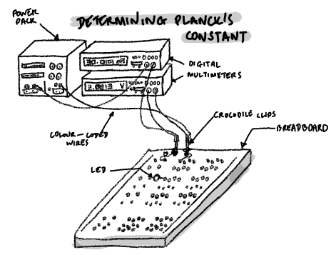

Figure 2: the Set-Up for Determining h[6]

Figure 3: the Circuit[7]

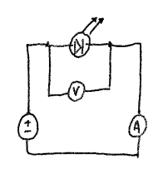A power pack was set up with two wires leading out connecting to both a multimeter on ammeter setting in series, as well as a multimeter on voltmeter setting in parallel across the breadboard inputs. A breadboard was placed with wires linking it to the input terminals, and various LEDs were placed across the breadboard to complete the circuit.

It was ensured that the diodes were placed the right way around so as not to compromise the circuit *(as current would not pass through)*. The wires were colour-coded for convenience *(i.e. black for negative terminal, red for positive terminal, blue for voltmeter, white for ammeter)*. Prior to supplying power to the board, the upper limit of the power-pack was set to 30mA in order to prevent the LED from burning. The voltage and current were then adjusted respectively so that the I-V characteristics *(and therefore, the threshold voltage)* for each LED could be determined.

1. Results, Uncertainties, and Discussion

Preliminary data was obtained prior to accurate data collection to roughly measure the value of VTas well as to gauge the voltage at the pre-assigned upper limit; it was previously decided to be 30mA. Additionally, the wavelengths of light emitted by the various diodes were obtained through the use of a spectroscope linked through to analytical computer software (see, LED Emission Wavelength Data).

Due to the relatively straightforward nature of the practical, it was decided that step sizes of roughly 0.05V increments would be used to obtain more data and reduce uncertainties, especially focusing on the linear portion of the graph since this would be from where the back-extrapolation would draw upon. For each diode, a voltage range above or around the visual threshold was used, up until roughly where the current was observed to be 30mA. Due to the shorter range of LED 4, smaller increments were used to obtain the equivalent amount of data.

|  |  |  |
| --- | --- | --- |
| **LED** | **Visual Threshold / V** | **Voltage at 30mA / V** |
| 1 | 2.88 | 3.40 |
| 2 | 2.40 | 2.97 |
| 3 | 1.80 | 2.43 |
| 4 | 1.69 | 2.02 |
| 5 | 1.66 | 2.30 |
| 6 | 1.98 | 2.30 |

**Table 1:** Preliminary data of voltage ranges across different LEDs.

The following data was obtained through the use of a spectroscope, and the *centroid wavelength* used in calculations. The uncertainty was calculated from data regarding the FWHM *(not noted below)* displayed on the processing software.

|  |  |  |  |  |
| --- | --- | --- | --- | --- |
| **Centroid Wavelength / nm** | **Peak/nm** | **FWHM/nm** | **Colour** | **Uncertainty**  **/ nm** |
| 405.35 | 404.29 | 11.97 | purple | 5.08 |
| 467.86 | 466.00 | 22.12 | blue | 9.39 |
| 594.97 | 595.81 | 15.56 | yellow | 6.61 |
| 608.53 | 609.59 | 12.91 | orange | 5.48 |
| 630.22 | 631.19 | 11.99 | red | 5.09 |
| 607.29 | 608.53 | 13.71 | green | 5.82 |

**Table 2:** Data obtained from spectroscope readings

The data in the proceeding column displays I-V characteristics, obtained across the breadboard *(i.e. not the power pack values)*.

|  |  |  |  |  |  |
| --- | --- | --- | --- | --- | --- |
| **LED** | **Observed Voltage/V** | **Observed Current/mA** | **LED** | **Observed Voltage/V** | **Observed Current/mA** |
| 1 | 2.89 | 0.75 | 4 | 1.70 | 0.15 |
|  | 2.91 | 1.08 |  | 1.75 | 0.44 |
|  | 2.96 | 2.34 |  | 1.80 | 1.25 |
|  | 3.04 | 5.83 |  | 1.85 | 3.50 |
|  | 3.10 | 8.73 |  | 1.90 | 8.10 |
|  | 3.15 | 11.91 |  | 1.95 | 14.36 |
|  | 3.20 | 14.96 |  | 1.98 | 18.75 |
|  | 3.25 | 18.19 |  | 2.00 | 22.51 |
|  | 3.30 | 22.11 |  | 2.03 | 27.54 |
| 2 | 2.40 | 0.15 |  | 2.04 | 30.87 |
|  | 2.45 | 0.41 | 5 | 1.65 | 0.06 |
|  | 2.50 | 1.08 |  | 1.79 | 1.34 |
|  | 2.55 | 2.29 |  | 1.86 | 3.20 |
|  | 2.60 | 4.28 |  | 1.90 | 5.11 |
|  | 2.65 | 6.29 |  | 1.95 | 7.26 |
|  | 2.71 | 9.70 |  | 2.00 | 10.29 |
|  | 2.75 | 12.66 |  | 2.06 | 13.36 |
|  | 2.83 | 18.52 |  | 2.08 | 14.94 |
| 3 | 1.89 | 1.43 |  | 2.15 | 19.42 |
|  | 1.96 | 3.39 |  | 2.20 | 22.61 |
|  | 1.99 | 4.89 |  | 2.25 | 26.50 |
|  | 2.05 | 7.49 | 6 | 1.90 | 1.88 |
|  | 2.10 | 10.24 |  | 1.94 | 3.73 |
|  | 2.15 | 13.00 |  | 1.97 | 5.23 |
|  | 2.20 | 16.07 |  | 2.02 | 7.89 |
|  | 2.25 | 18.98 |  | 2.06 | 7.81 |
|  | 2.31 | 22.66 |  | 2.11 | 14.28 |
|  | 2.35 | 25.50 |  | 2.16 | 18.42 |
|  | 2.40 | 28.71 |  | 2.20 | 21.83 |
| **N.B:** This data enclosed in this table has been rounded to 2.d.p. The original data was recorded to a precision of 4.d.p. for the voltage, and 2.d.p. for the current readings to neglect the effect of fluctuations *(see Sources of Uncertainty)*. | | |  | 2.25 | 25.89 |
|  | 2.30 | 29.89 |

**Table 3:** The current-voltage characteristic data obtained from. A link to the raw data can be found in the *Appendix* section.[8]

|  |  |  |  |  |
| --- | --- | --- | --- | --- |
| **LED** | **Colour** | **VT / V** | **λ / nm** | **1/λ / nm-1** |
| 1 | purple | 2.971782768 | 405.35 | 0.002467004 |
| 2 | blue | 2.572119806 | 467.86 | 0.002137392 |
| 3 | yellow | 1.938565669 | 594.97 | 0.001680757 |
| 4 | orange | 1.89396365 | 608.53 | 0.001643304 |
| 5 | red | 1.863550774 | 630.22 | 0.001586747 |
| 6 | green | 1.933707728 | 607.29 | 0.00164666 |

**(P.T.O) Table 4:** Data used to obtain gradient, and ultimately, *h*.

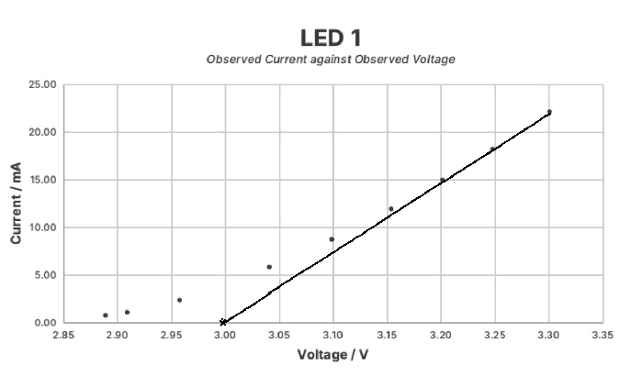

Figure 4: I-V Characteristics of LED 1 (purple)

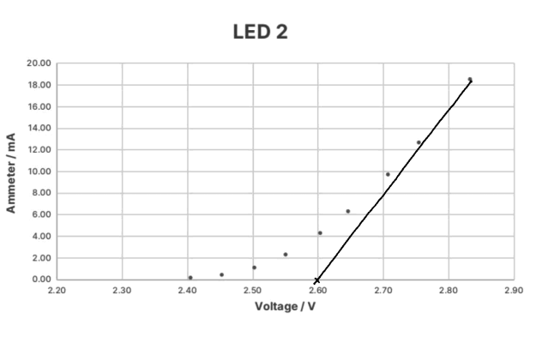

Figure 5: I-V Characteristics of LED 2 (blue)

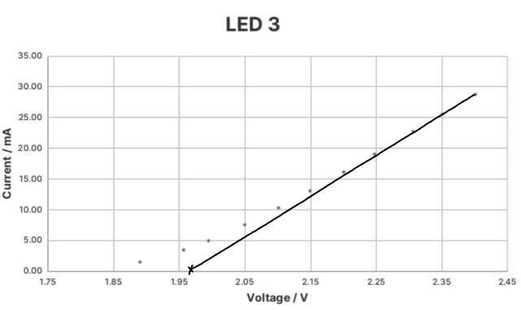

Figure 6: I-V Characteristics of LED 3 (yellow)

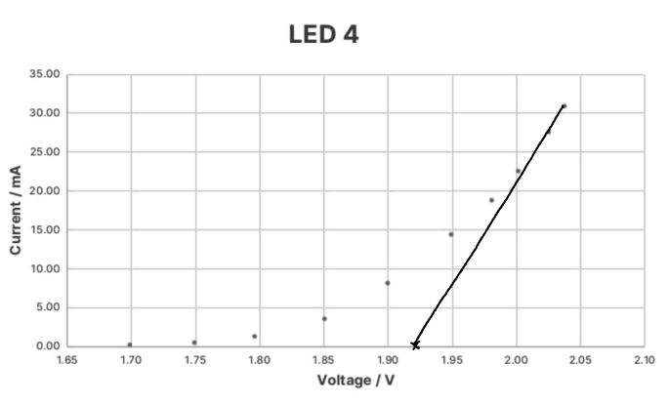

Figure 7: I-V Characteristics of LED (orange)

_______________________

**Appendix 1:** the above graphs

In *Figure 5* and *Figure 7*, in order to keep the current under the 30mA threshold that was pre-assigned, fewer data points were collected in the linear portion of the graph for the back-extrapolation.

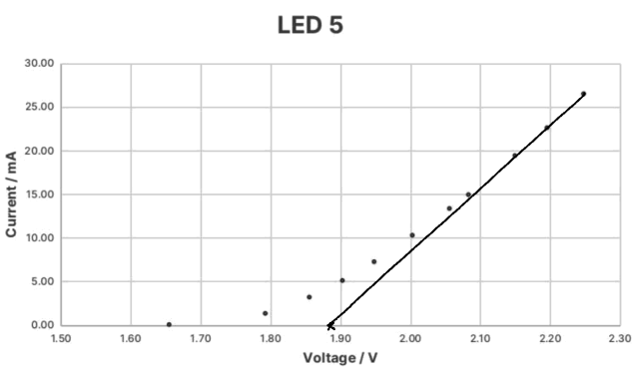

Figure 8: I-V Characteristics of LED 5 (red)

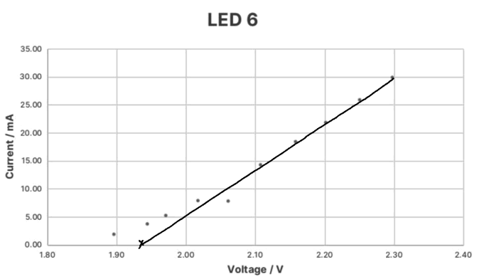

Figure 9: I-V Characteristics of LED 6 (green)

Following this, the data from Table 4 was plotted to give the graph below, including *two-way* error bars.

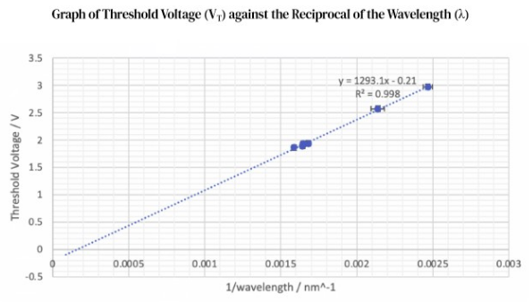

1. Conclusion

Our final calculated value of g was (6.90±0.25)×10-34J.s, which was relatively close to the accepted value of 6.63×10-34 J.s, but still outside of our uncertainty range.

1. References, Appendices

1. *Planck’s constant* was defined to have this exact value of 6.62607015×10-34J.s, when expressed in SI Units, as of November 4, 2021

   <https://physics.nist.gov/cgi-bin/cuu/Value?h> , National Institute of Standards and Technology *(NIST).*
2. i Andrews, David (2000). p54, An Introduction to Atmospheric Physics, Cambridge University Press
3. Liddle, Andrew (2015). p16-17, An Introduction to Modern Cosmology, John Wiley & Sons, Obtained from Google Books
4. Semiconductor Band Theory is explained in depth in the Appendix 1 of the lab manual provided for this experiment on Blackboard.
5. Source: <https://web.phys.ksu.edu/vqm/laserweb/Labs/Labi-v/LAB-IV3.gif>
6. Figure 2: Hand-drawn sketch, drawn by Martin He *(i.e. me)*
7. Figure 3: Hand-drawn sketch, based on circuit diagram on Blackboard
8. Please find raw data, code and uncertainty calculations such as at the following Github: <https://github.com/martin-he543>